FLASHMASTER – Exam Helper App

1. Introduction
Students often face difficulty during exam preparation because they have to manage multiple subjects, notes, PDFs, assignments, and important concepts at the same time. Traditional study methods such as reading textbooks repeatedly or maintaining handwritten notes may not always help with quick revision and concept recall. Students may also struggle to create effective study schedules and monitor their learning progress.
FLASHMASTER is designed to solve these problems by providing a smart digital study assistant platform. It helps students organize their study materials, generate flashcards automatically, create topic-wise study plans, and track preparation progress. The platform makes revision faster, easier, and more effective during exams.

2. Description
FLASHMASTER is a web-based Exam Helper Application developed using the MERN Stack (MongoDB, Express.js, React.js, Node.js). The platform is designed to help students improve their study habits and prepare efficiently for exams by organizing learning materials and providing smart revision tools.
The application allows students to upload study resources such as notes, PDFs, text files, images, or topic summaries. After uploading the material, the system automatically generates flashcards containing important questions, definitions, formulas, and keywords. These flashcards help students quickly revise concepts without reading the entire material repeatedly.
The platform also allows students to organize materials subject-wise and topic-wise. Students can create personalized study plans by selecting subjects, exam dates, study hours, and important chapters. Based on this information, the system generates a structured study schedule to help students complete preparation on time.
FLASHMASTER includes progress tracking features that allow students to monitor how many chapters they have completed, how many flashcards they have revised, and which topics still require more attention. The platform can also display performance reports and learning analytics to help students identify their weak areas.
Students can mark flashcards as easy, medium, or difficult, and the system can suggest more revision for difficult topics. The application also supports reminders and notifications so that students stay consistent with their study plans.
The platform ensures secure login and role-based access. Students can manage their own study materials and flashcards, while administrators can manage users, monitor uploaded content, and maintain the overall system. FLASHMASTER creates an organized and efficient learning environment that improves revision speed, memory retention, and exam preparation.

3. Scenario-Based Case Study
Sneha is preparing for her semester exams and has multiple subjects to study, including Data Structures, DBMS, and Operating Systems. She has notes and PDFs for all subjects but finds it difficult to revise quickly before exams.
- User Registration/Login: Sneha creates an account and logs into FLASHMASTER.
- Upload Study Material: She uploads PDF notes for Data Structures and DBMS.
- Flashcard Generation: The system generates flashcards containing important definitions, formulas, and questions.
- Study Plan Creation: Sneha enters her exam dates and study hours, and the system creates a daily study plan.
- Topic Revision: She revises flashcards topic by topic and marks difficult questions for later review.
- Progress Tracking: FLASHMASTER shows how many chapters she has completed and how many are still pending.
- Notifications: Sneha receives reminders to complete her daily study targets.
- Exam Preparation: By following the plan and using flashcards regularly, Sneha prepares effectively for her exams.

4. Technical Architecture
The FLASHMASTER platform includes the following components:
- Frontend Application: Built using React.js to provide an interactive and responsive user experience.
- Backend Server: Built using Node.js and Express.js to manage APIs and business logic.
- Authentication Module: Handles secure registration, login, and role-based access.
- Study Material Module: Allows students to upload and organize study resources.
- Flashcard Generation Module: Generates flashcards automatically from uploaded material.
- Study Plan Module: Creates personalized study schedules and reminders.
- Progress Tracking Module: Tracks completed topics, revision status, and performance.
- Notification Module: Sends study reminders and deadline alerts.
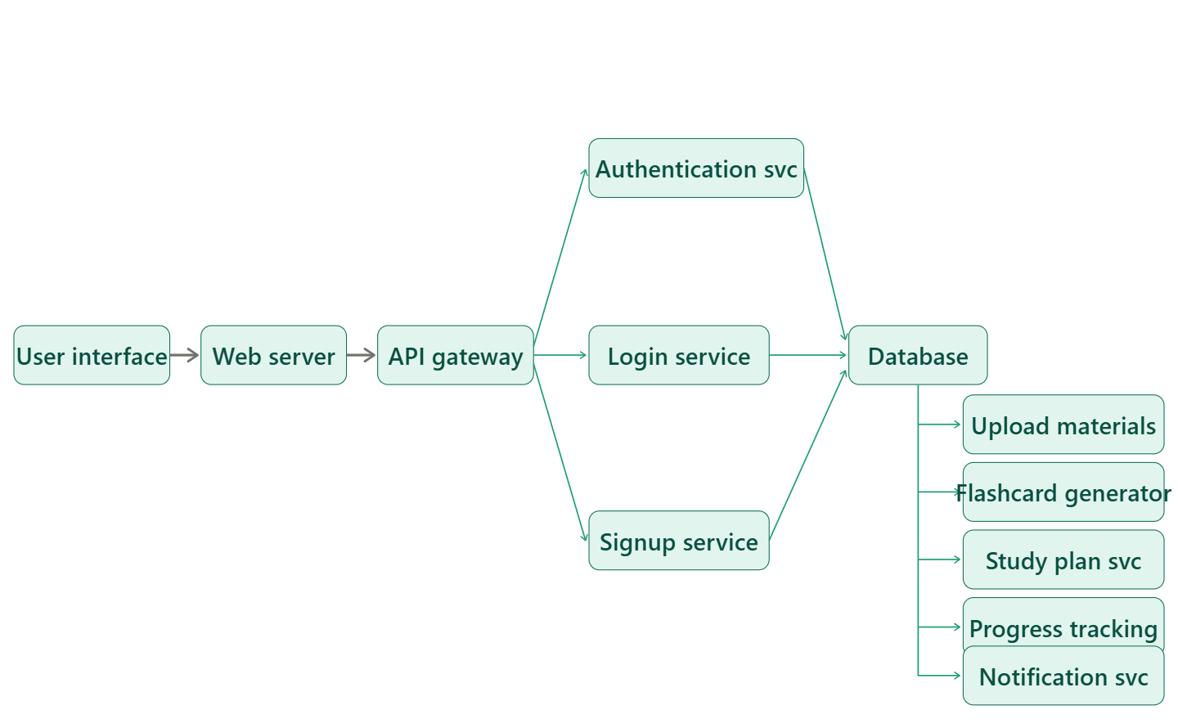
- Database: MongoDB stores users, study materials, flashcards, plans, and progress data.
- Admin Dashboard: Helps administrators monitor users, uploaded content, and reports.

5. ER-Diagram & Relationships
The major entity relationships in FLASHMASTER are:
- Student-Material Relationship: One student can upload multiple study materials.
- Material-Flashcard Relationship: One study material can generate multiple flashcards.
- Student-Study Plan Relationship: One student can create multiple study plans.
- Student-Progress Relationship: One student can have multiple progress records.
- Student-Notification Relationship: One student can receive multiple reminders and notifications.
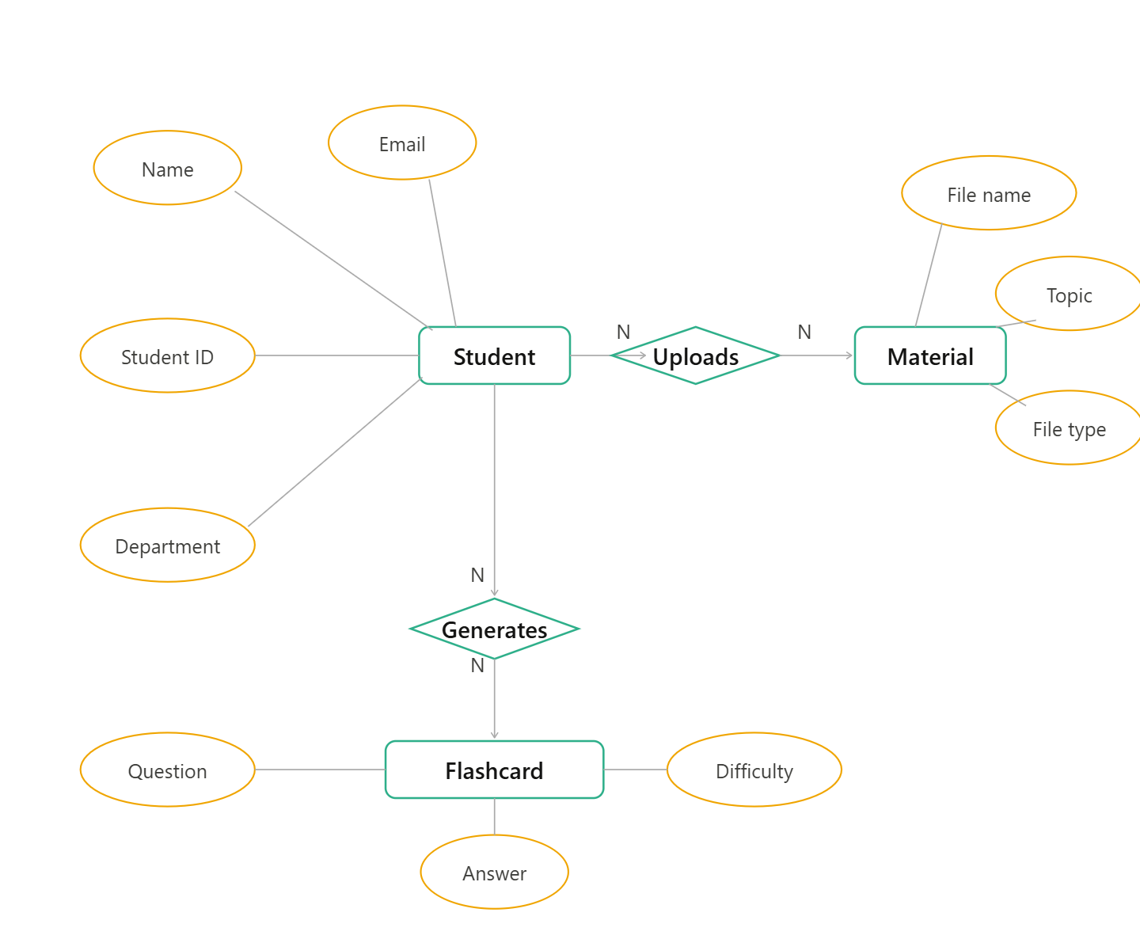
These relationships help organize study content and improve revision management.

6. Project Flow
Student registers/logs in → Uploads study material → System generates flashcards → Creates study plan → Revises flashcards → Marks difficult topics → Tracks progress → Receives reminders → Completes revision → Logout.
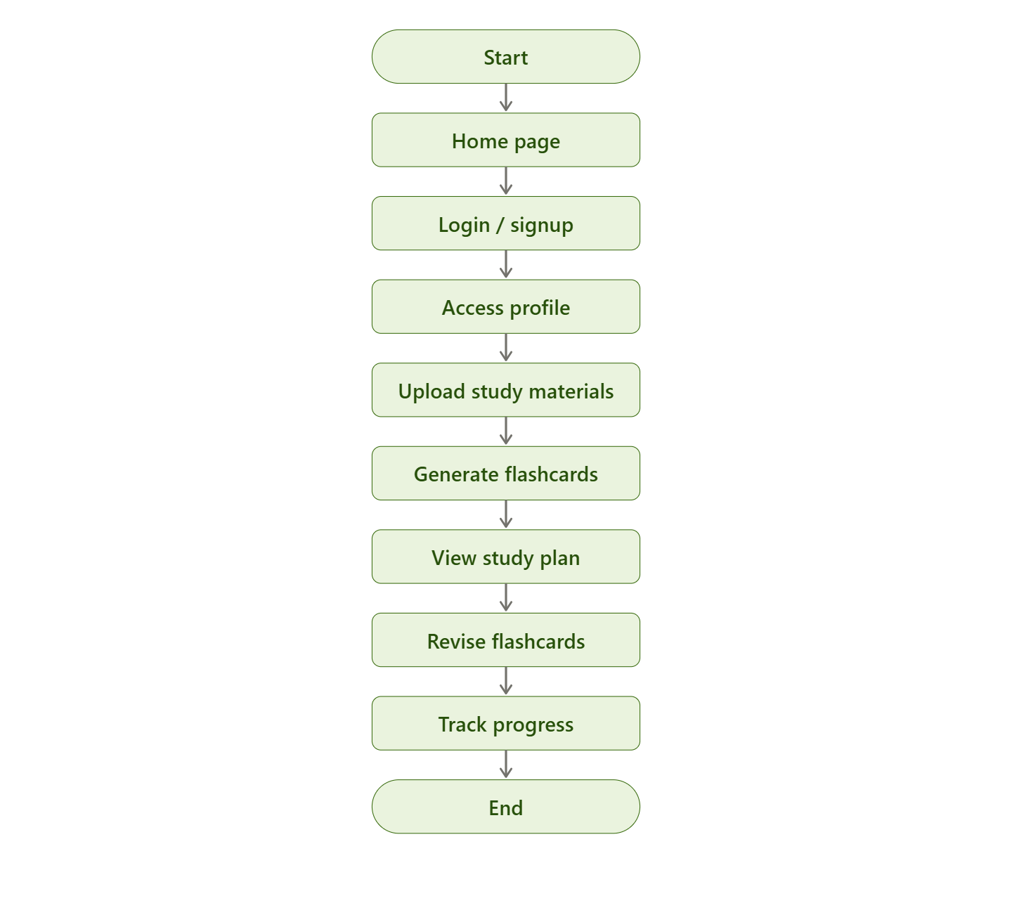
Admin logs in → Monitors users and uploaded content → Reviews reports → Manages notifications → Maintains platform performance.

7. Pre-Requisites
Students should know:
- Basics of JavaScript
- ES6 Concepts
- Node.js fundamentals
- Express.js basics
- MongoDB basics
- REST APIs
- Basic React
- CRUD Operations
- Authentication basics
- State management basics

8. Required Technologies
- Frontend: React.js, HTML, CSS
- Backend: Node.js, Express.js
- Database: MongoDB
- Authentication: JWT, bcrypt
- Tools: Postman, Git, GitHub
- Optional: Cloudinary for file uploads
- Optional: OCR API for extracting text from images and PDFs

9. Suggested Database Collections

Users Collection
{
"name": "Sneha",
"email": "sneha@example.com",
"password": "hashed_password",
"role": "student"
}

Study Materials Collection
{
"userId": "user_id_reference",
"subject": "Data Structures",
"title": "Linked List Notes",
"fileUrl": "notes.pdf"
}

Flashcards Collection
{
"materialId": "material_id_reference",
"question": "What is a linked list?",
"answer": "A linked list is a linear data structure where elements are connected using pointers."
}

Study Plans Collection
{
"userId": "user_id_reference",
"subject": "DBMS",
"examDate": "2026-05-15",
"dailyStudyHours": 3
}

Progress Collection
{
"userId": "user_id_reference",
"completedTopics": 8,
"pendingTopics": 3,
"revisionStatus": "In Progress"
}

10. Key Features
- User Authentication
- Study Material Upload
- Automatic Flashcard Generation
- Topic-Wise Organization
- Study Plan Creation
- Progress Tracking
- Notifications and Reminders
- Flashcard Difficulty Levels
- Performance Analytics
- Admin Dashboard
- Role-Based Access Control
- File Upload Support

11. Optional Advanced Features
- AI-Based Flashcard Generation
- OCR Text Extraction from PDFs and Images
- Voice-Based Flashcard Reading
- Real-Time Collaboration with Friends
- Leaderboard for Study Progress
- Pomodoro Timer Integration
- Quiz Generation from Flashcards
- Dark Mode
- Multi-language Support
- PDF Summary Generation

12. Learning Outcomes
By completing this project, students will learn:
- Full Stack Development
- REST API Design
- Authentication and Authorization
- MongoDB Database Design
- CRUD Operations
- File Upload Management
- Study Data Analysis
- Role-Based Access Control
- React State Management
- Real-world Project Structure
- Deployment Basics

13. Roles and Responsibilities

Student
- Register and login securely
- Upload study materials
- Generate and revise flashcards
- Create study plans
- Track progress
- Receive reminders and notifications
- Mark difficult topics

Admin
- Manage users and uploaded content
- Monitor study reports
- Handle system maintenance
- Ensure secure access
- Generate analytics and reports

